**Chap Chap(Location based mechanical Advertisement Service)**

# **Project Introduction**

This is a location-based service provider and advertiser for mechanical services. It helps people in marginal areas find mechanical services and its mechanics in marginal areas find services easily. This application is essential to all people who own vehicles.

# **Software Architecture**

It consists of three modules: Client, Garage and Admin Modules. The two modules, client and garage modules serve the two main customers, the service providers and the customers while the admin module is used for user management and administration. The client module is responsible for displaying the registered garages to the use based on the user location. The garage module is where the garage manages its customers and receives payments.

## Project Architecture

The three modules are all client applications, they access a singular API and based on their roles they can access various parts of the application. Below is a system diagram showing the application structure and how it interacts with the API.

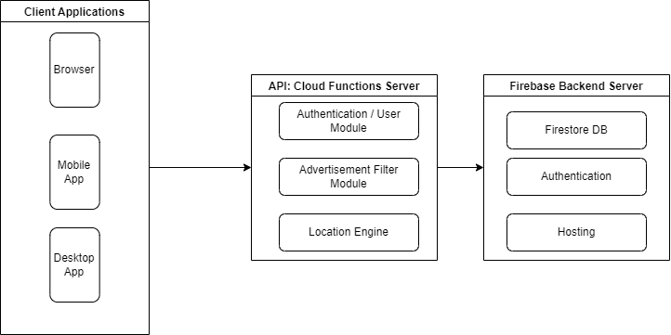

Project Architecture

The application is built using flutter as its frontend client and firebase with cloud functions for its API and databases. Below is an overview of the application architecture and its system diagrams with its app screenshots.

### Client Application

This is built using flutter as the core application UI framework. Flutter is a cross-platform UI framework built by google to enable developers develop beautiful applications with great user experience. The UI is component based, i.e. It has various UI elements that are rendered differently based on the application state.

This application consists of various pages with many of them shared across the various client modules. The application logic and screens are outlined below

#### Auth Component

This component is responsible for user authentication and user verification. This is where the user signs in, sign up as a user administrator. This component consists of four screens: Onboarding screen, Login screen, Register screen and User verification component.

The Auth component user flow is as simple as illustrated below. In this diagram, when the user authentication by the login module succeeds, the user role is fetched and the user verification module presents the user to choose with role the user can login into the application using after fetching the roles the user registered into, from the choice the user is directed into the desired screen fit for the role.

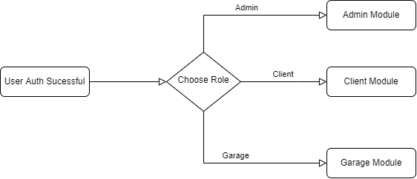

**Auth component system diagram**

Below are the screens for the modules.

##### 1. Login Screen

This screen is responsible for user login

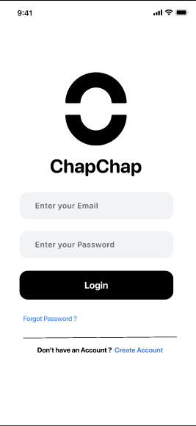

Login Screenshot

##### 2. Register Screen

This screen is responsible for user registration

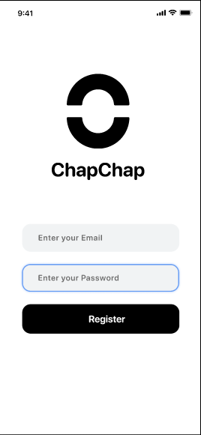

Register Screenshot

##### 3. Forgot password

This screen is responsible for resetting password

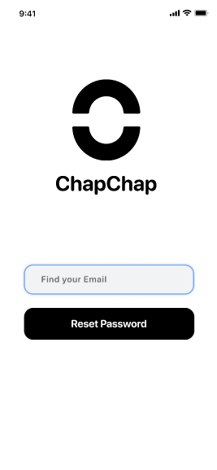

Forgot Password Screen

##### 4. Choose Role

This is where the user chooses the screen to log into

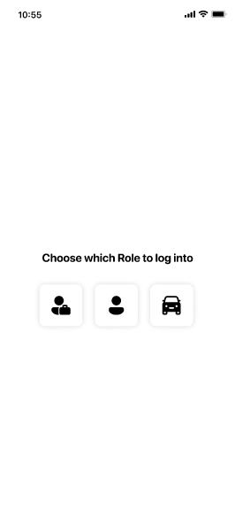

Choose Role screenshot

#### Home Component

This is the first component the user interacts with after login in. This component is made up of three screens, they include: client screen, garage dashboard and admin dashboard. The three screens handle the user, garage and admin respectively.

The role of the user determines which screen the user will access, below are the various screens for the various userbase.

##### Client Screen

This is the screen a customer and a normal user will use. It consists of a map where the user would be able to select a garage near him/her easily, a search area for manually searching for service centers.

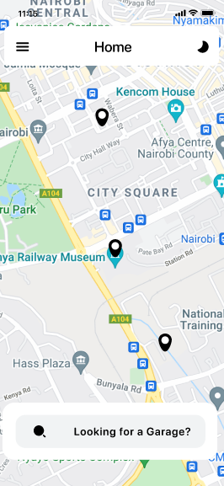

Client screenshot

##### Garage dashboard

This screen is where garage managers will be able to manage their garages in the platform.

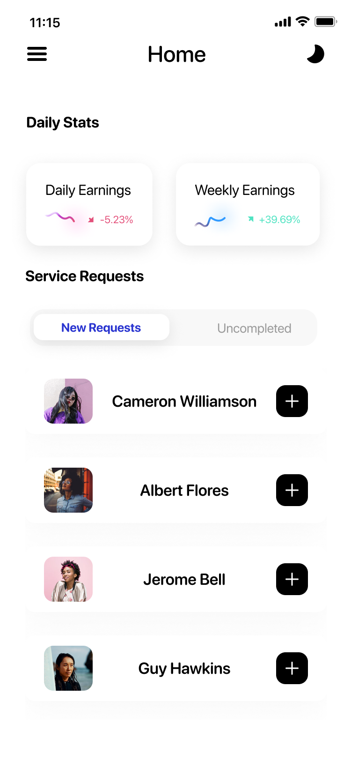

##### Admin Screen

This is where the application administrator can control users behavior, verify users and service providers etc.

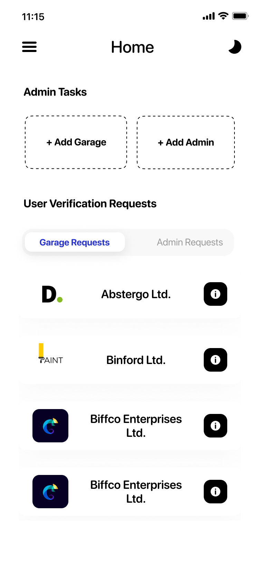

Admin Screenshot